LOGO RESULTS

The official project logo of the partnership
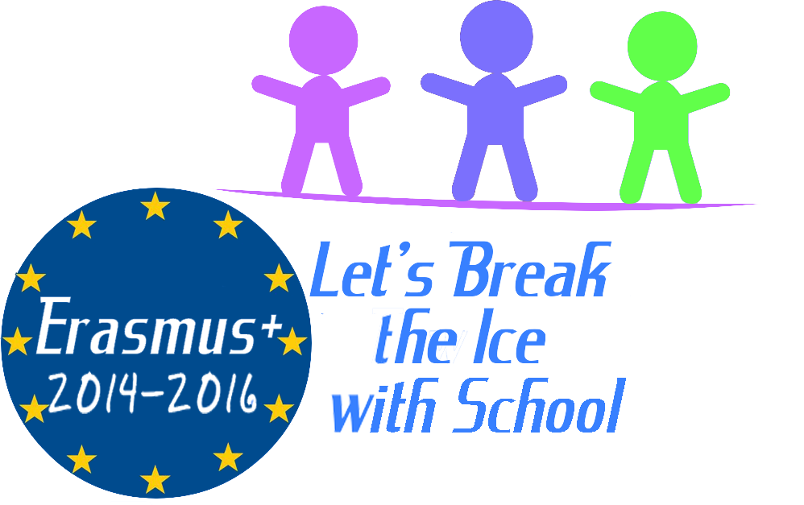

The best exhibition idea
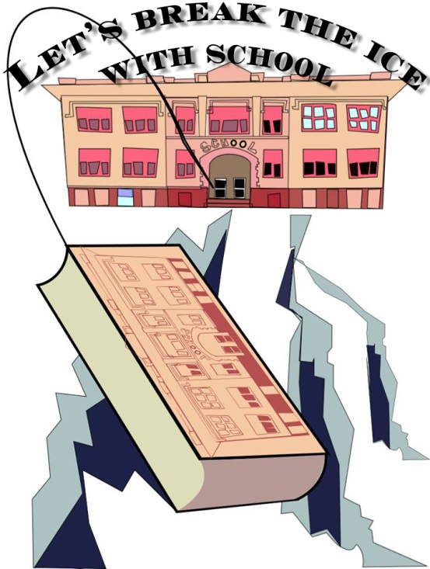

Evaluation committee: LATVIA – Inese Aleksejeva
TURKEY – Neslihan Sen
BULGARIA – Pepa Golemanova

