SCHOOL DESCRIPTION

Jelgava situated just 42 km away from capital Riga and Baltic sea.
Population: 64 279
Territory: 60,32 km2
Climate: Warm summer and spring, relatively mild autumn, cold winter. First frosts are observed in the begining of October; first snowfalls happen in December; snow melts by the end of March.
The origins of Correspondence School of Jelgava Local Municipality are found in 1967 when, on the basis of DDP Executive Committee decision of Jelgava district starting with the 4th quarter of the study year 1966/1967, there was an extramural department organized at Eleja secondary school.
Correspondence School of Jelgava Local Municipality, in the form as it is today, started its activity in 1996 when the school was accredited.
The main goals of the school from the very beginning are – to provide individuals with opportunities to raise the general level of education and to create the foundation for further education and self-education.
Correspondence School of Jelgava Local Municipality has worked and is still working on the basis of consultation places. Currently there are Svete, Skibe and Centre consultation places.
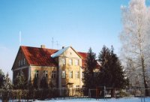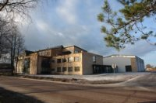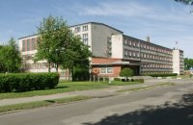
It has 285 students from 27 municipalities, as well as 25 students living abroad. At school work 73 teachers, 15 teachers are Master's Degree.
Modern school is unimaginable without novelty and changes in the study process. Students from all over the world study in our school, so our teachers have to be flexible and be able to work with today`s technologies.
Correspondence School of Jelgava Local Municipality is one of the few Latvian schools that offer students to acquire secondary education through Distance Learning.

THEORY OF MULTIPLE INTELLIGENCES
Howard Gardner offers the theory of Multiple Intelligences. This theory argues that humans are borned with biopsyhological potential which consist of the different equal types of abilities and skills. For now, H. Gardner has emphasized eight different types of abilities.

The theory of multiple intelligence is successfully used in the learning process as abroad as in Latvia. How this knowledge can be used in daily work with students and what benefits can it bring for teachers and students?
First, taking into account that people get knowledges about the world by differently, we respect each individuals’ way of acquiring knowledges and give an opportunity to study using the most suitable form, e.g. words, visuals, movement etc. Hence, we can help discover each student’s uniqueness, help them fully to use their abilities and make them able to use all available means they have.
Second, the theory of multiple intelligence opens an opportunity to vary the learning process: to use learning methodology, materials and even classroom equipment that corresponds to different types of intellect. However, we have to remember that it is not possible to use single approach to all students in the class, i.e. for one part of students the chosen method can work very successfully but for the other part it could be unsuitable, because it should be taken into account that variety of teaching techniques for the students with multiply intelligence. Therefore, the teacher has to use as many different methods as it can, in order to involve student into the learning process, by making it more creative, exiting and interesting.
Third, taking into account individual way of teaching of each student, it becomes possible to encourage his motivation to learning process as well as raise his self-assessment. Often taking care of passive students, it is usually made one mistake that inappropriate method is applied to the particular type of student intelligence which results in unbelief in his abilities. If that student during one hour could use different types of intelligences, possibly he would prepare for the next class with the increased interest and work at the lesson with pleasure knowing that he can complete the exercise successfully.
Fourth, this approach can also be used in behaviour and discipline problem solving. For instance, if student with prevailing wording intelligence has discipline problems, the conflict can be solved through conversation. Student has to be motivated to read more books that comprise advices which can be used in solving of conflict. Moreover, student have to practice his ‘inter-dialogue’ in order to develop self-control. Of course, student’s age and level of understanding have to be taken into account in order to be sure that information that he deals with is understandable. In this case it would be very useful to ‘play’ such situations in different roles and develop student’s ability to keep self-discipline and self-control in stress situations through exercises based on psychical activities, e.g. relaxation or breathing exercises. If student with main intelligence – kinaesthetic, is hyperactive during the lesson, he should be given an exercise corresponding to his type of intelligence.

How does this theory benefit by applying it at school?
For student:
- Opportunity to realize himself; choose things that interest him the most and things that he is doing better that anything else
- Discover new abilities and skills
- Possess an opportunity to participate in the learning process emotionally
- Develop responsibility
- Different ways of presentation are offered and introduced (very important because of the thick study process high school students mostly answer in written form)
For teacher:
- Such approach doesn’t take much time, therefore makes learning process more effective and productive – learning material is absorbed in a short time
- Motivate teacher to work in a more creative and free manner
- Allow to get to know the personality of students
[Skolu atbalsta centrs, 2000]

NATURALIST
Dr. Howard Gardner added the Naturalist Intelligence to his list in 1996. It is the first addition to the original seven. This intelligence has to do with observing, understanding and organizing patterns in the natural environment. A naturalist is someone who shows expertise in the recognition and classification of plants and animals. This could be anyone from a molecular biologist to a traditional medicine man using herbal remedies.
Examples of naturalists might include George Washington Carver, Rachel Carson, Charles Darwin, or a child who skillfully sorts and classifies rocks, insects, shells, or dinosaurs. These same skills of observing, collecting, and categorizing might also be applied in the "human" environment as witnessed in a child sorting sports cards, or an adult who shrewdly distinguishes between the sounds of different engines or analyzes the variations in fingerprints.
[Gardner, H., 1996]
A Menu of Instructional Strategies for the Naturalist Intelligence
- Collecting data
- Collecting objects from the natural world
- Labeling and mounting specimens from nature
- Organizing collections
- Observing nature
- Doing experiments in nature
- Noticing changes in the environment
- Sorting articles from nature
- Categorizing objects
- Classifying information
- Keeping notebooks
- Learning names of natural phenomena
- Learning characteristics of the natural world
- Using magnifiers or microscopes to study nature
- Using binoculars or telescopes to study nature
- Drawing or photographing natural objects
- Nature hikes or field trips in nature
- Gardening
- Caring for pets
- Wildlife protection projects
- Setting up winter feeding stations for wild animals or birds
- Comparing natural observations with others
- Visiting zoos and botanical gardens
- Visiting museums of natural history
- Drying flowers
- Studying books about nature [3]

Nature science abilities - is interested about the nature: plant, animals, the phenomena of nature and rocks; collects objects of nature and herbarium, distinguish facts about nature, classify flare and fauna; observe the nature and make notes; work in the garden and take care of pet animals.
How to develop this intelligence:
- During the walk telling about the nature and its process
- Tell about trees, animals and plants
- Tell about the nature protection and its significance in our life (eco-thinking)
- Encourage to help in the garden
- Visit the Nature museums and real encyclopaedias

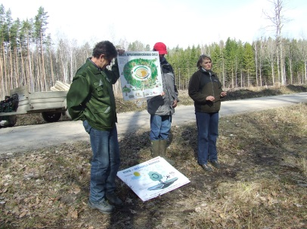 | 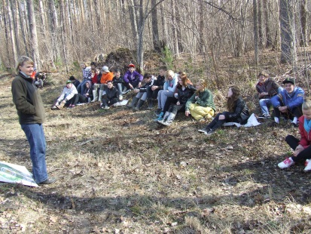
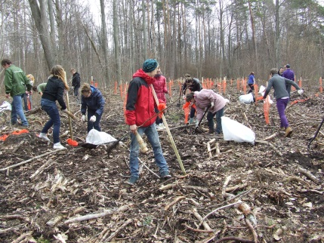 | 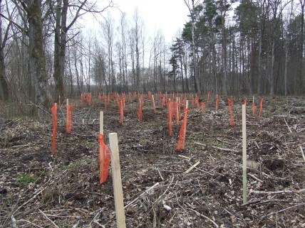

INTRAPERSONAL

Intrapersonal type of ability is an ability understand and distinguish your own feelings as well as knowledges about your strengths and weaknesses.
Intrapersonal ability: pays attention to its inter world; revalue and analyse experienced events; know himself; realize emotions and thoughts; make his own opinion about the issues; be able to solve global philosophical problems of nature; possess strong will.
Recommended exercises and activities
Activities | Exercises
Individual tasks;  Autonomous studying;  Choose of means of learning;  Individual research | Find different ways of solving an exercise;  Always analyse made mistakes;  Complete exercises based on your own plan

How to develop this intelligence:
- Talk about current emotions
- Give an opportunity to express opinion
- Give an opportunity to fix mistakes and solve problems independently
- Teach that each case must be done until the end and only then it is possible to start another

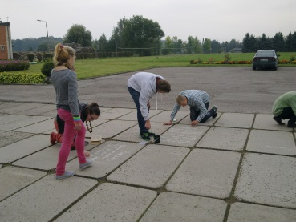 | 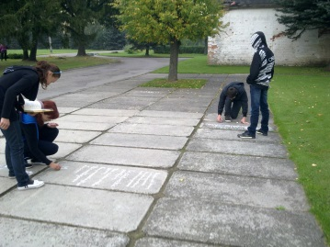
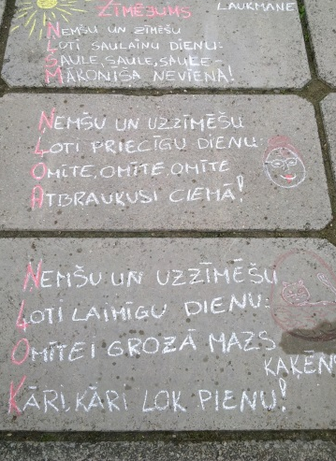 | 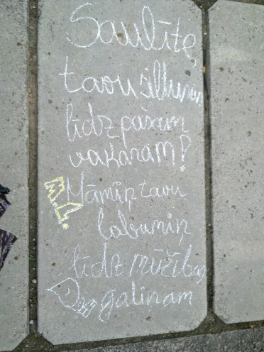

REFERENCES

- Gardner, H. Intelligence : multiple perspectives / Howard Gardner, Mindy L. Kornhaber, Warren K. Wake. Fort Worth : Harcourt Brace College Publishers, 1996.

- Daudzpusīgā intelekta teorija skolā. Pieredzes materiāls. Rīga: Skolu atbalsta centrs, 2000.

- http://education.jhu.edu/PD/newhorizons/strategies/topics/mi/campbell.htm

